Web service 21600331 Hanjae bae

1. http://localhost:8088/php/tournament/lastprj.html

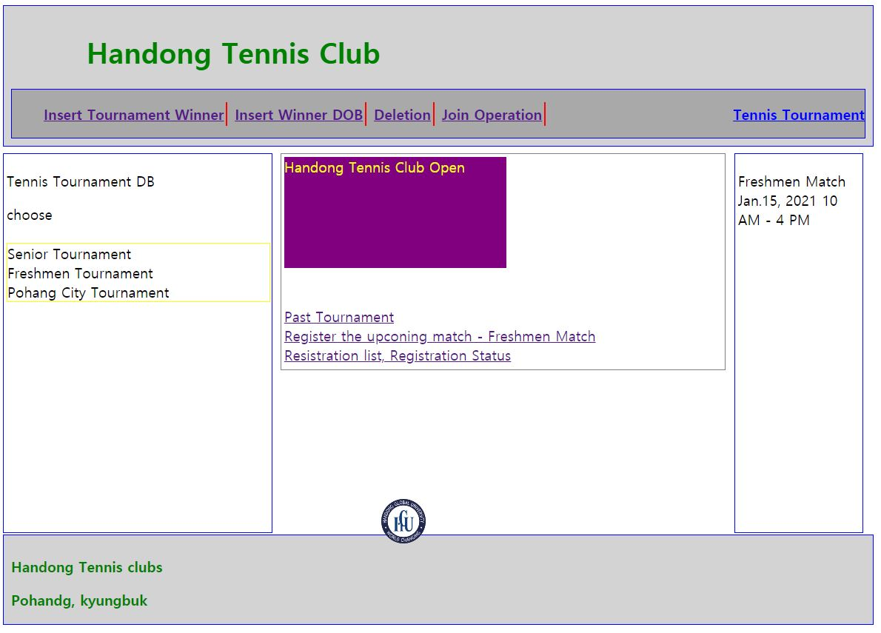

2. http://localhost:8088/php/tournament/TennisTournament.php

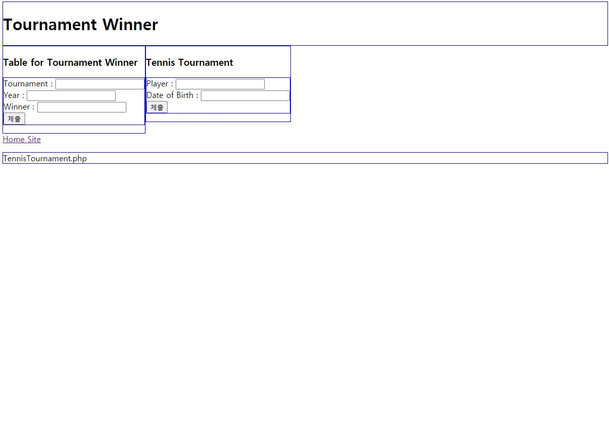

3. <http://localhost:8088/php/tournament/TournamentWinnerTable.php>



4. <http://localhost:8088/php/tournament/PlayerDOB.php>



5. <http://localhost:8088/php/tournament/cancelTwoRecords.php>

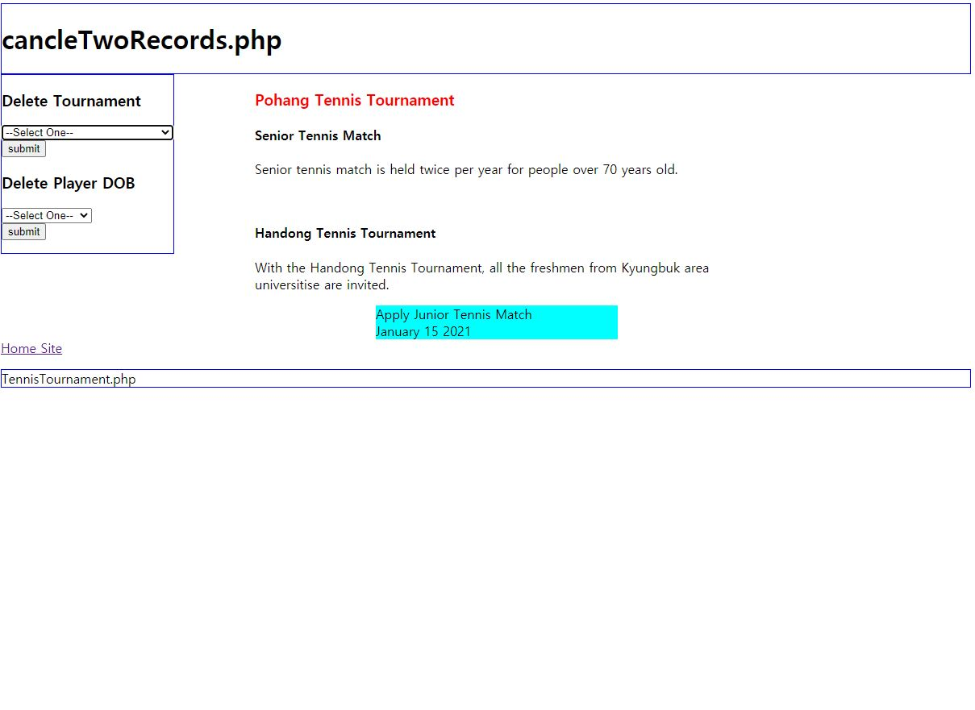

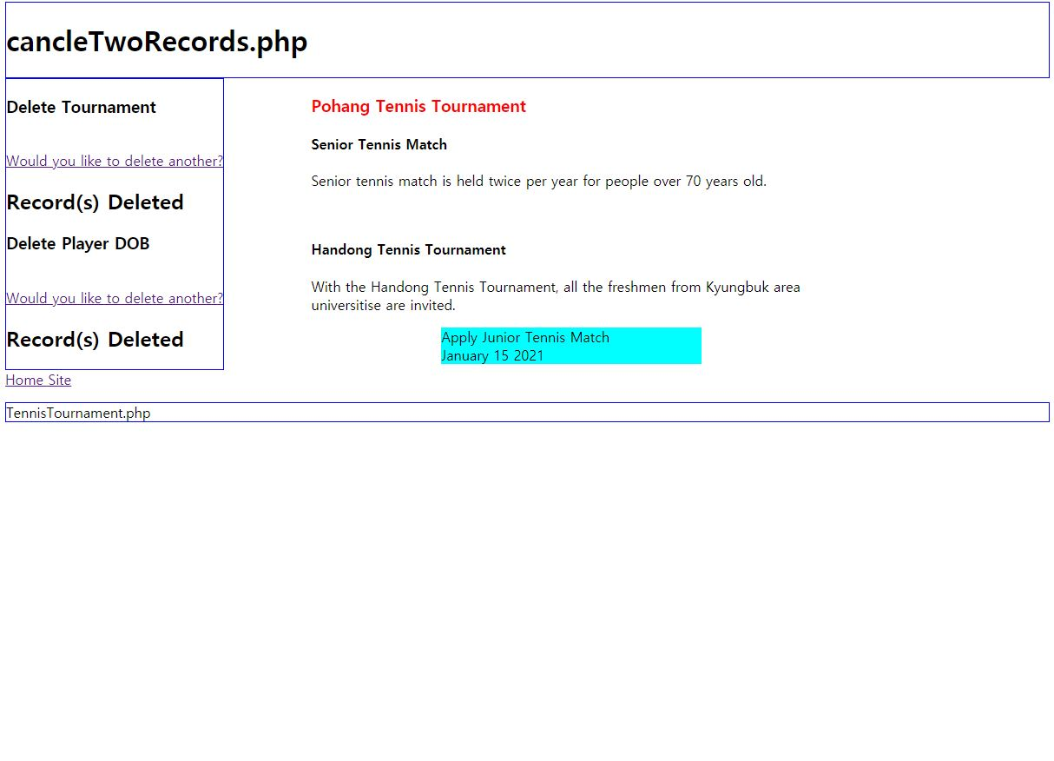

6. <http://localhost:8088/php/tournament/TournamentDOBJoin.php>



7. <http://localhost:8088/php/tournament/TournamentDisplay.php>



8. <http://localhost:8088/php/tournament/RegisterMatch.php>

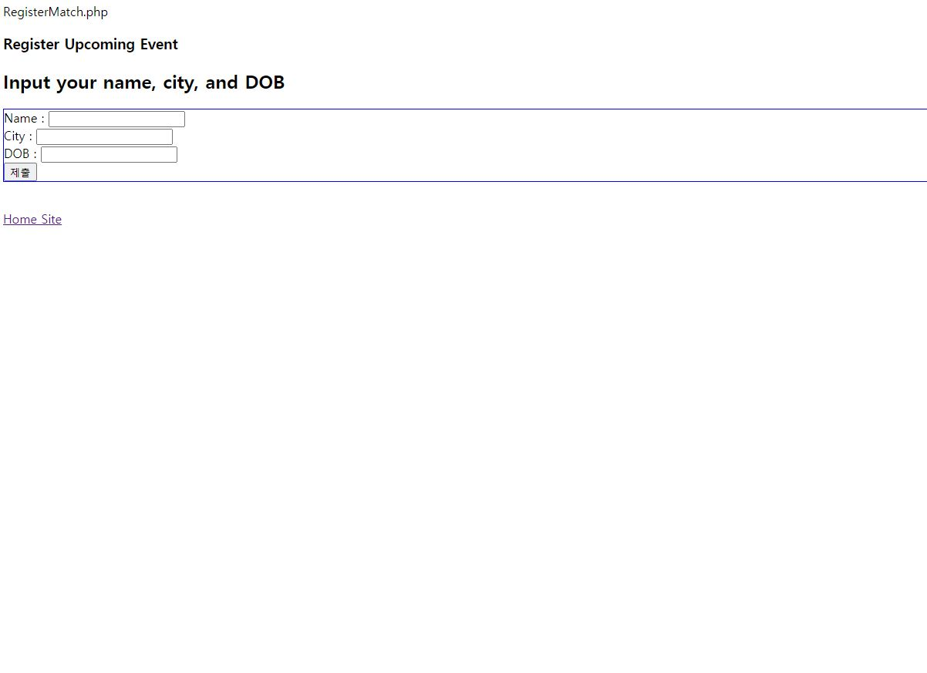

9.http://localhost:8088/php/tournWament/RegistrationDisplay.php

